**EXERCISE NO.3**

**DATE:14/10/2020**

**AIM:**

To write a python program to remove and print every second number from the list of numbers until the list becomes empty.

**PROGRAM:**

def removenumber(no):

p=2-1

id=0

lenoflist=(len(no))

while lenoflist>0:

id=(p+id)%lenoflist

print(no.pop(id))

lenoflist-=1

A=list()

n=int(input("Enter the size:"))

print("Enter the n")

for i in range(int (n)):

p=int(input(""))

A.append(int(p))

print("After remove")

removenumber(A)

**LINK:**

[**http://103.53.53.18/mod/vpl/forms/submissionview.php?id=231&userid=1743**](http://103.53.53.18/mod/vpl/forms/submissionview.php?id=231&userid=1743)

**OUTPUT:**

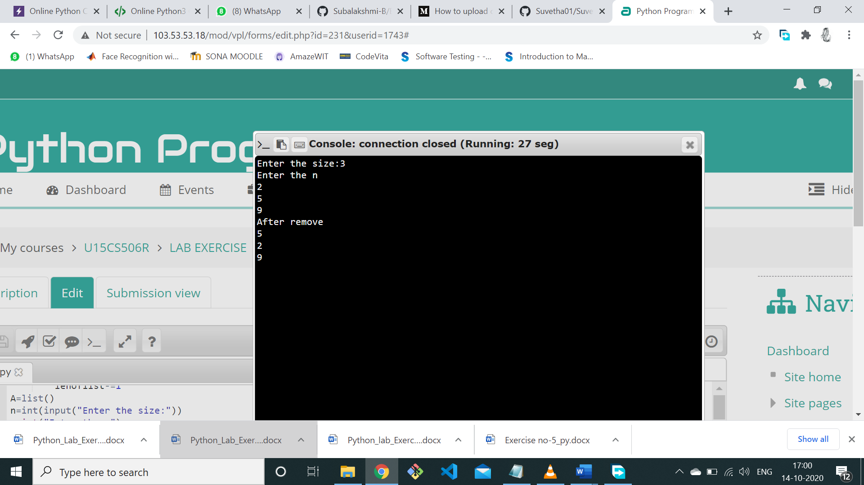

**RESULT:**

Removing and printing every second number from the list of numbers is done.